Personal Safety for Children and Young People
Last year, we also highlighted a recent paper in the Harvard Review of Psychiatry, ‘How Well Do We Understand the Long-Term Health Implications of Childhood Bullying?’ by Zarate-Garza, et al. which stated; “a woman who has been bullied as a child is 27 times more likely to have a panic disorder as a young adult. Among men, childhood bullying resulted in an 18-fold increase in suicidal ideation and action.” And we summarised that if schools focused on teaching their pupils self defence so that they can effectively defend themselves, plus empower all pupils to go to the aid of others who are being bullied, this would take away the imbalance of power, and reduce school bullying.

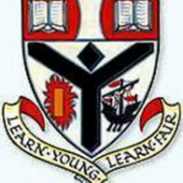
Workshops for 512 pupils at Auchenharvie Academy took place in October and November 2023.
This was followed by more Personal Safety workshops at Auchenharvie Academy in February and March 2024 for 344 pupils. It is our hope that we will see a reduction in school bullying in this school and others plus, with the introduction of our five-year programme in Auchenharvie Academy (now in its third year), that we will see a local reduction in domestic abuse, knife crime and sexual assaults as these pupils progress into adulthood. Time will tell if our training will have the impact we are hoping for.

Comments included;

“I really enjoyed it and I would like to have more training sessions in the future.”
“I liked the stats and the different scenarios”
“There were blind people teaching us and I loved hearing their stories”
“They did teach us a lot of self defence and I would like it if they visited us more.”

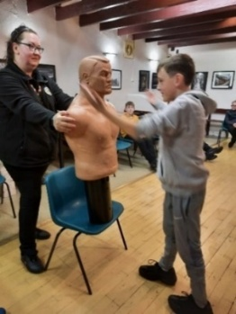
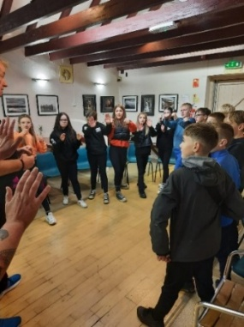
In September 2023, we provided our empowering Personal Safety workshops to various youth groups in the Three Town area and followed this up with further training in April 2024. A total of 115 youths aged 10-12 years old were taught.

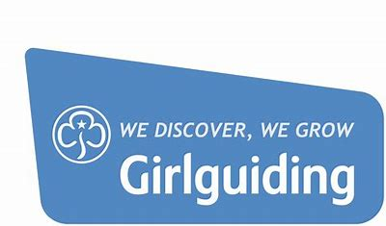
3rd Ardrossan Girl Guides had an empowering Personal Safety workshop in January 2024. Margaret Agnew, Guide Leader, commented; “Thank you for showing the girls at 3rd Ardrossan Guides how to safely defend themselves. They loved it and I’ve recommended your training to other groups.”
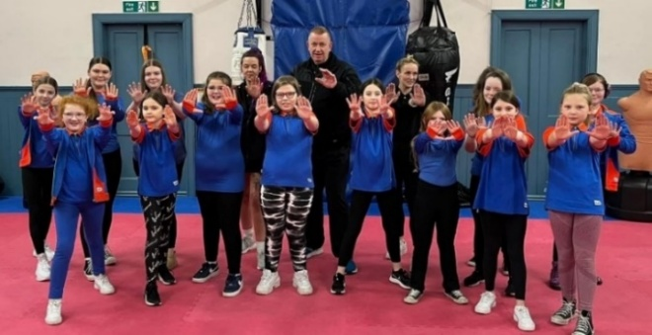
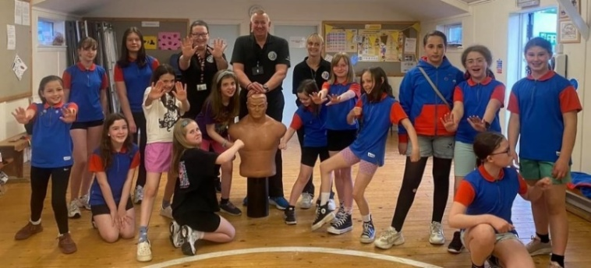
This was followed by a workshop for 1st Stewarton Girl Guides in May. Guide Leader, Lauren Hussain commented; “The feedback from the girls was great, they thoroughly enjoyed it. They said they now know how to defend themselves if they were being attacked and they would like you to come back at the end of the year and show them different things.”

