**Photographs from concerts and activities**

Practice session Open day concert

Scottish Festival of Brass Spring concert 2024

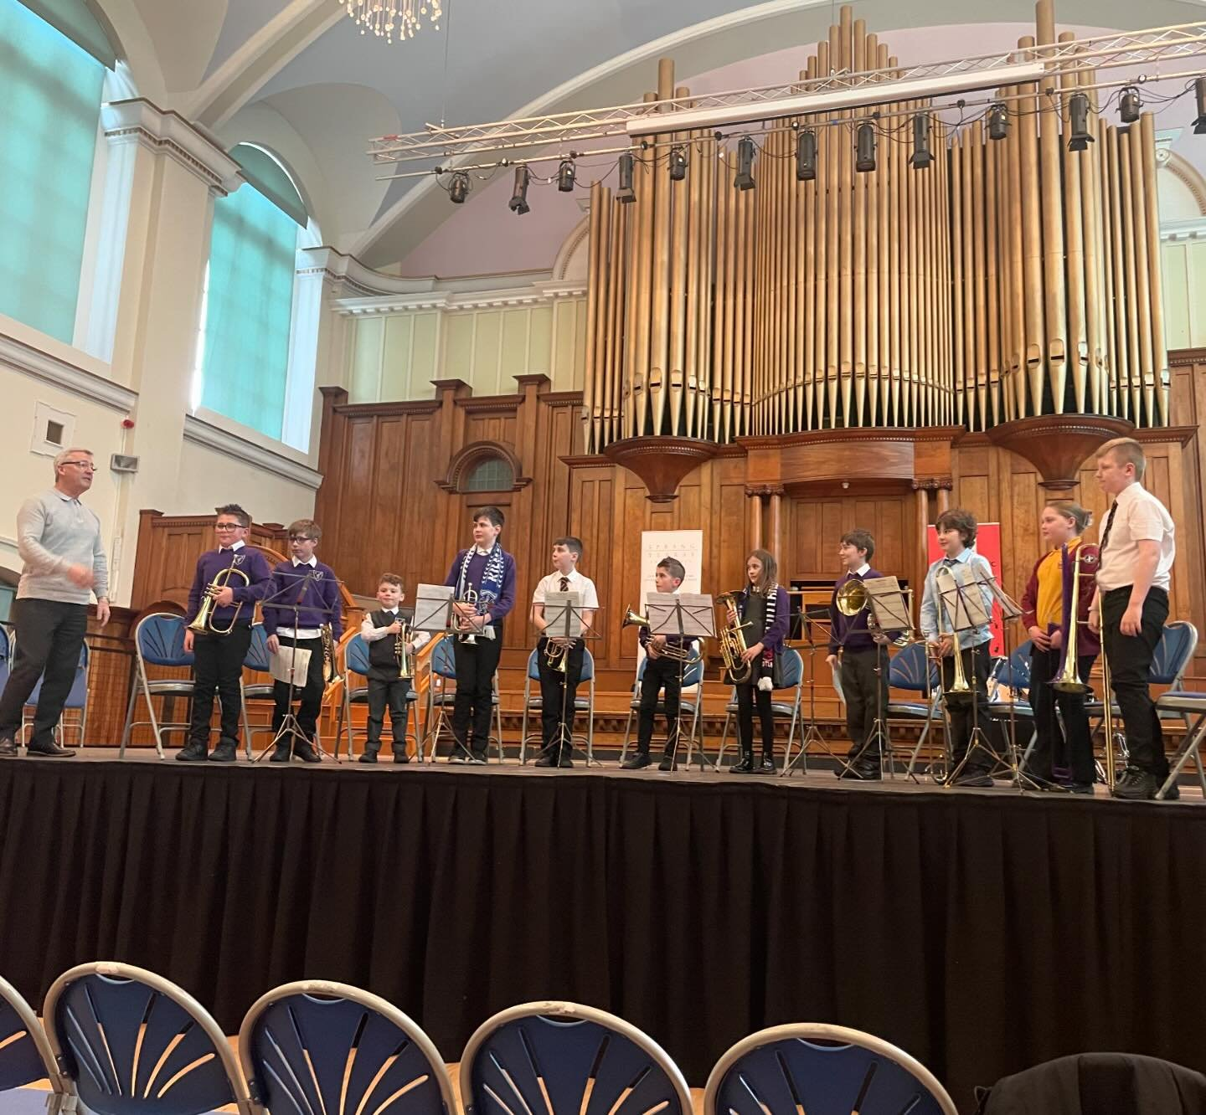

Spring concert 2024 Ayrshire music festival