# Barrmill Fairy Trail

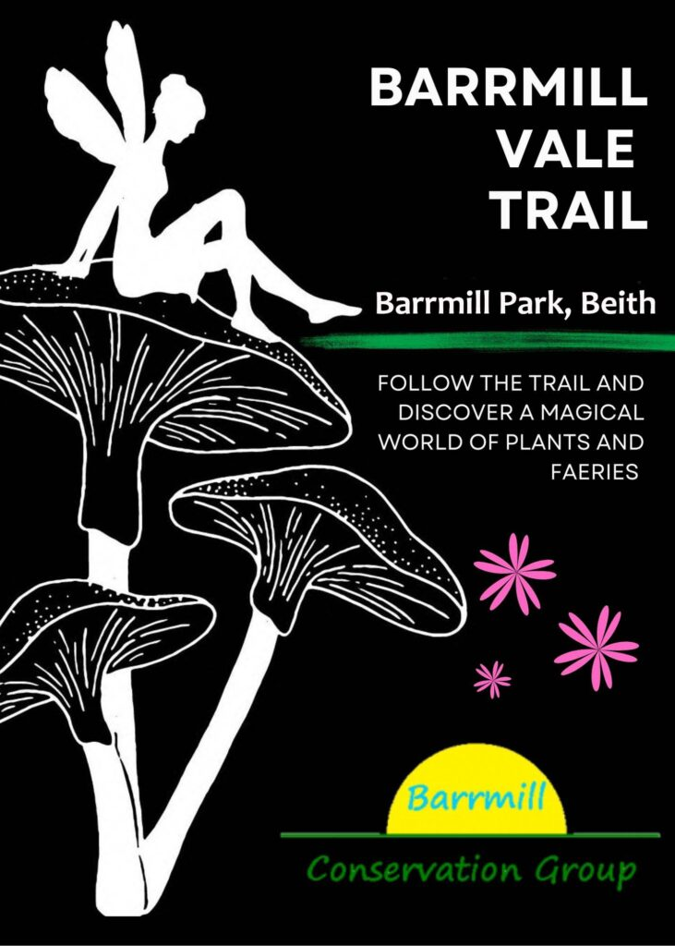

Explore the powers of your imagination along the woodland fairy trail as you hunt for fairy doors and houses. You will encounter the portraits of the fairy spirits who look after the special trees, plants and flowers found along the trail. Solve the fairy riddles, as your journey in nature soon becomes a real quest for enlightenment and knowledge through Druidic teaching.

Enter Barrmill park, across the Vale Burn bridge, over the stream and head straight on along the main path, veering to the right at the rockery for the Vale Grove entrance. This walk takes you through a tunnel of trees deep inside an old quarry dug into the mountainside hundreds of years ago at the very beginnings of Barrmill as a village.

The most ancient wood spirits of Barrmill live here, working their good magic, protecting the ferns and mosses and hawthorns, the very oldest of plants that grow here. Look for the different gnome houses. At one with the minerals, earth and soil of the land, they are all completely made of natural materials and skilled ancient woodcraft .

Passing the Toad Abode and Frogpile log homes for our familiar amphibians, you will see the ancient Spring of Life with its protective Well Cairn up on the banking. The waters here are magic and healing, oozing out from their pure underground source and trickling down to replenish and cool.

Within the depths of the Grove, time stands still and you are removed from this world to an inner place of tranquillity where only the birdsong and whisper of leaves remains. Take time here to listen carefully and develop your senses. Stop at the Fairy Well where you can leave offerings of kind thoughts and cleanse your mind. Here you are cloaked in complete protection.

Then behold, as you reach the end of the first stage of your adventure. Turn at the small circle and meet the tall tree-carved figure. At this Druids’ Grove, our mighty Wizard watching from above is here to provide guidance and impart to you his ancient wisdom. Take time to be in awe at his presence but also remember his humility within the woods. He is of the woods, as you are now, and always with you and of you, his good kinsfolk and people. Once we all depended on looking after and regenerating the woods for our very survival and livelihood and he has not forgotten.

From now on, look for his words of wisdom and the special advice from all the elements of the land as you venture even further along, past the colourful Foxglove Hill on your left and Hazel Tree Hill on your right, on your way up and onwards to the very top of the mountain path .

And did you catch sight of the White Stag beyond the Portal or did you miss this most elusive of creatures and guardian to the secrets of the Deeper Wood?

Rest a while at the Olympic Garden Clearing with its two very special trees, the Toffee Apple or Katsura tree on the left and the Spindle tree growing in the island bed on right. The wood from this tree was used for making the spindle on spinning wheels.  
Emerge from the Vale Grove and into the sunlight where you can arise to admire the Greenhills views over the famous Braes o’ Barrmill .

Descend the grassy hill and veer right alongside our sandy Bee Bank to the bottom of the Vale View streamside path. Cross the timber boardwalk and follow the path round to find yourself in the Fossil Grove. Barrmill is a place long famous for its limestone quarries full of sea creatures and their fossils. And within the ferny fronds here, there might even be a baby dinosaur hatching.  
Think of yourself now on a mission of self-development; your own personal evolution as you steadily arise from these ancient times. As you ascend the path towards the future, you pass through the many ages of civilised thought and evolve as a person through acquiring cultural quotations, knowledge and mindfulness. Leave behind your stress and troubles, think afresh and be born anew.

As you arrive back at the park entrance, take in mind that everyone has the power to make someone else smile today and that each journey in life begins with a single step, or in the case of a wee frog, a single hop. You have already accomplished the first big step.