**AWR FC Local Resident Survey Findings**

Forms response chart. Question title: Q1. Do you currently take part in any Sports, Fitness or Wellbeing Activity? 
. Number of responses: 188 responses.

Q2. If Yes, what activities do you take part in?

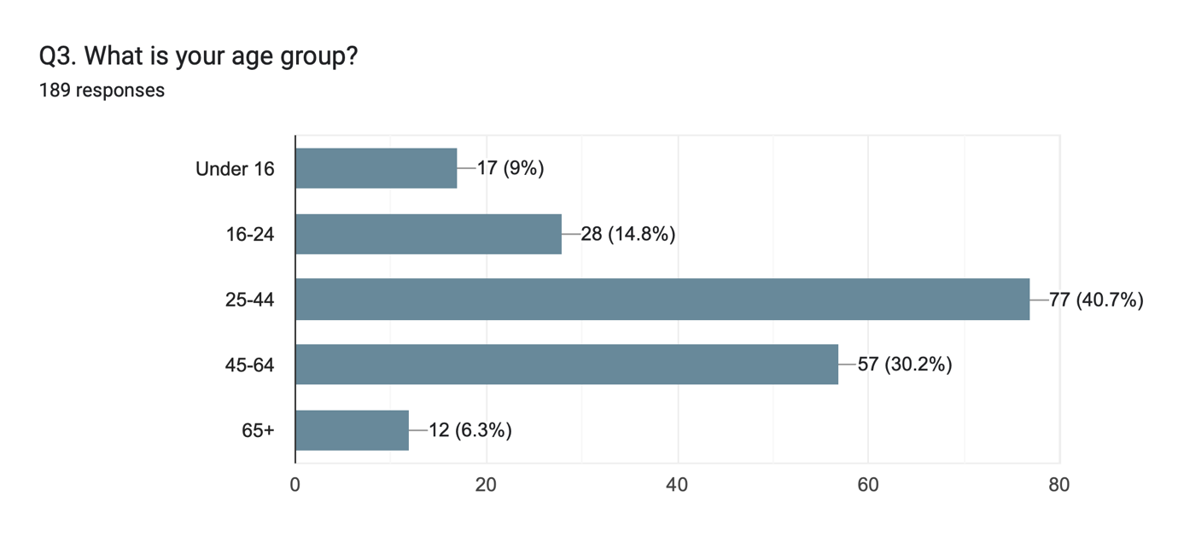

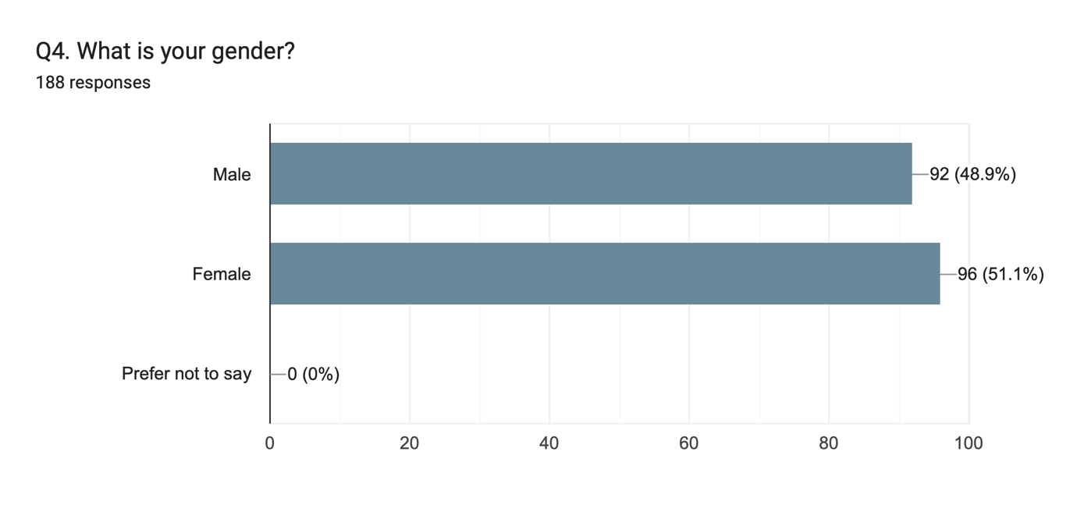

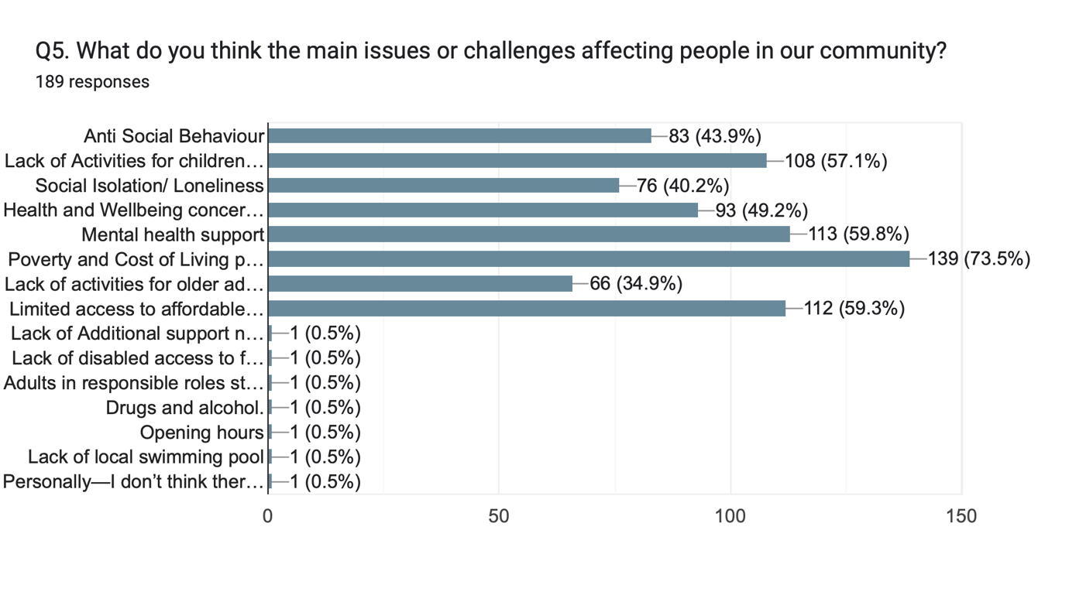

In response to Question 5, which asked residents about the main issues or challenges affecting the community, the most commonly mentioned concern was **poverty and cost of living pressures**, cited by **73.5%** of respondents. This was closely followed by concerns around **health and wellbeing** (**72.5%**) and **mental health** (**59.8%**). A **lack of local activities** was highlighted by **65.1%**, pointing to a gap in accessible and inclusive opportunities. **Anti-social behaviour** was flagged by **43.9%**, while **social isolation and loneliness** were identified by **40.2%** of participants. These results indicate a clear need for community-led responses that address affordability, improve health, and create spaces for connection and positive engagement.

**Q6. In your own words, what do you feel are the biggest priorities for improving life in our community?**

**Affordable and Accessible Activities**

Many residents highlighted the need for low-cost and accessible local services, especially given cost of living pressures.

**Examples:**

* “Having more accessible activities.”
* “Providing affordable activities.”
* “Making activities more accessible and cost friendly.”

**Support for Young People**

There was strong concern about opportunities for young people, both in terms of structured activity and long-term life direction.

**Examples:**

* “More stuff for young people to do to help combat antisocial behaviour.”
* “Education for adults/teens that have left school. Subsidised sports and/or hobbies for school-age kids.”
* “We should introduce national service for kids that leave school—will give them a sense of purpose, discipline and a routine.”

**Health and Wellbeing**

Respondents saw physical and mental health as a priority, with calls for activities that support healthier lifestyles and reduce isolation.

**Examples:**

* “Wellbeing and mental health awareness.”
* “If people knew that the gym not only improves physical health but mental health also.”
* “Exercise is an excellent way to improve physical and mental health and in turn quality of life.”

**Facilities and Spaces**

A number of people emphasised the need for better or more varied facilities where community life can take place.

**Examples:**

* “Saunas, steam room, recovery from gym.”
* “Having wider range of high-quality facilities and resources.”

**Community Engagement and Cohesion**

Respondents expressed a desire for more opportunities to come together as a community—particularly through events and informal spaces.

**Examples:**

* “A lot more activities and community spaces.”
* “Ban headphones to make people socialise!”
* “More opportunities for shift workers, more social events.”

**Employment and Skills**

Some residents highlighted the importance of job creation and skills development to improve long-term prospects and confidence.

**Examples:**

* “Creating jobs and opportunities for people.”
* “Improved employment opportunity.”
* “Employment opportunities.”

**Education and Lifelong Learning**

There were a few mentions of supporting learning and education across age groups.

**Example:**

* “More support for Mental Health”

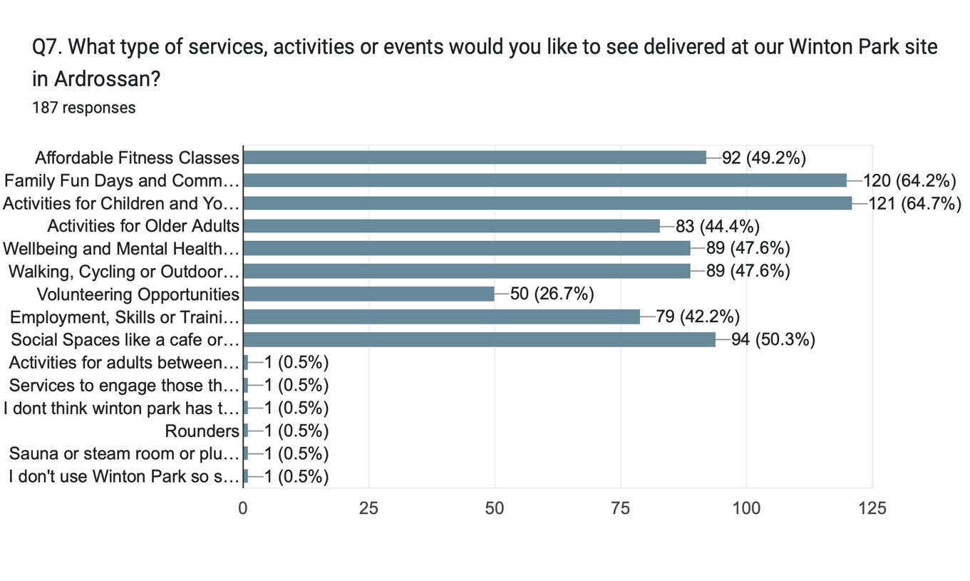

In response to Question 7, which asked residents what types of services, activities or events they would like to see at Winton Park, the most popular suggestion was for **activities for children and young people**, identified by **64.7%** of respondents. This was closely followed by **family fun days and community events** (**64.2%**) and **social spaces or cafés** where people can connect (**50.3%**). Other frequently mentioned priorities included **affordable fitness classes** (**49.2%**), **volunteering and employment support** (**49.2%**), **walking, cycling or outdoor fitness** (**48.1%**), and **mental health and wellbeing support** (**47.6%**). Activities for **older adults** were also highlighted by **44.4%**, reflecting a broad community desire for inclusive, intergenerational, and wellbeing-focused programming at the site.

Q8. Are there any new sports, activities, facilities or clubs you'd like to see introduced locally?

Summary of Resident Suggestions

**Support for Young People**

There is strong demand for more structured, engaging options for young people, including clubs and multi-activity sessions.

**Examples:**

* “A youth club at the bottom of the town.”
* “More clubs for teenagers.”
* “A circuits activities class to allow young people to try a different range of activities to see which one they like.”

**Affordable and Accessible Activities**

Affordability was again a recurring theme, with suggestions to make gym and sports access cheaper and more inclusive.

**Examples:**

* “Free gym introduction days for larger groups of people.”
* “There are plenty of sports activities—they're just not affordable.”
* “Multi-sport classes at affordable prices.”

**Health and Wellbeing**

Residents suggested activities that combine physical health with mental wellbeing, and that consider barriers like childcare and men’s mental health.

**Examples:**

* “Fitness classes for families… to support those who can’t get childcare.”
* “There is a real shortage of men’s mental health groups.”
* “Groups offering education on self-management of wellbeing before it becomes a problem.”

**Education and Lifelong Learning**

A number of suggestions were made for ongoing adult learning through health-oriented classes.

**Examples:**

* “Spin classes.”
* “Self-defence classes.”
* “Daytime dance classes, yoga and Pilates. So more of these.”

**Community Engagement and Cohesion**

Several ideas focused on getting people outdoors and together through social, inclusive, and group-based activity.

**Examples:**

* “Knitting groups, dog socialisation, walking groups.”
* “Coastal rowing in the Three Towns—it's inclusive, gets people exercising and meeting others.”
* “Depends on needs… happy to provide links to community programmes that work in London.”

**Facilities and Spaces**

There were a few targeted suggestions for specific new clubs or facilities that residents felt were missing.

**Example:**

* “Badminton club.”