**Photographs from concerts and activities**

**Our building – Dunlop Hall Dreghorn dedicated to John Boyd Dunlop inventor of the pneumatic tyre**

**Our 3 different bands in action**

**Youth groups**

Scottish Festival of Brass 2023

March – Spring concert March – Spring concert

**Community Band**

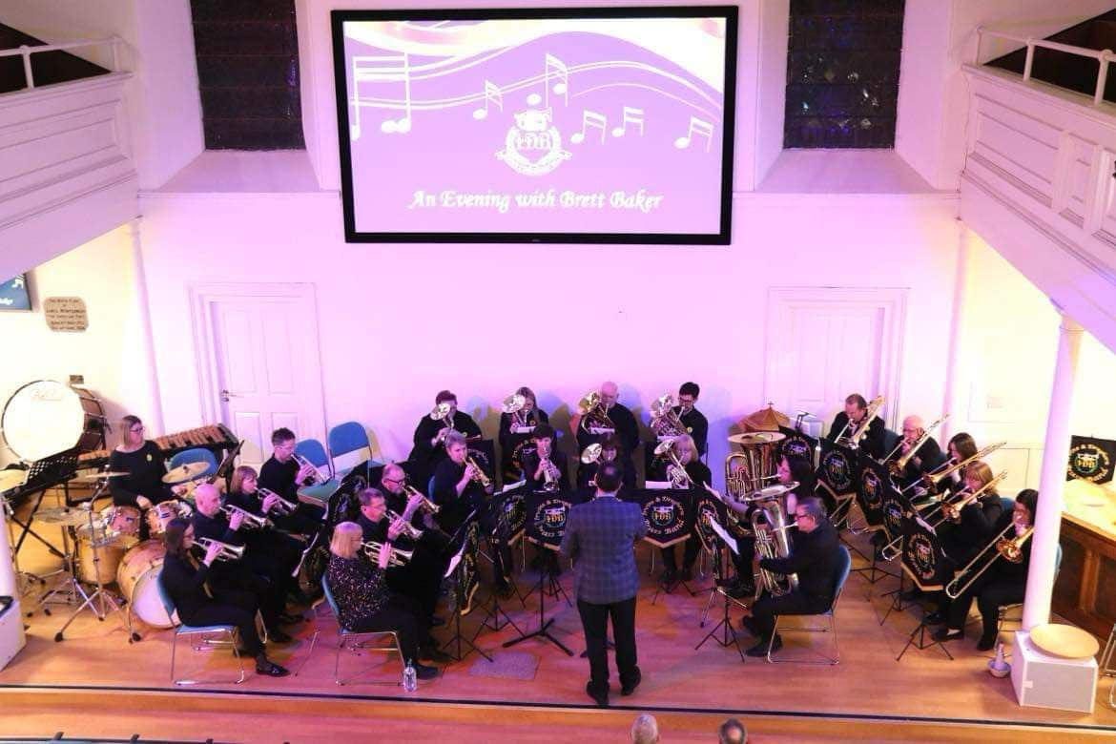

Christmas concert Community band in action

**Contest Band**

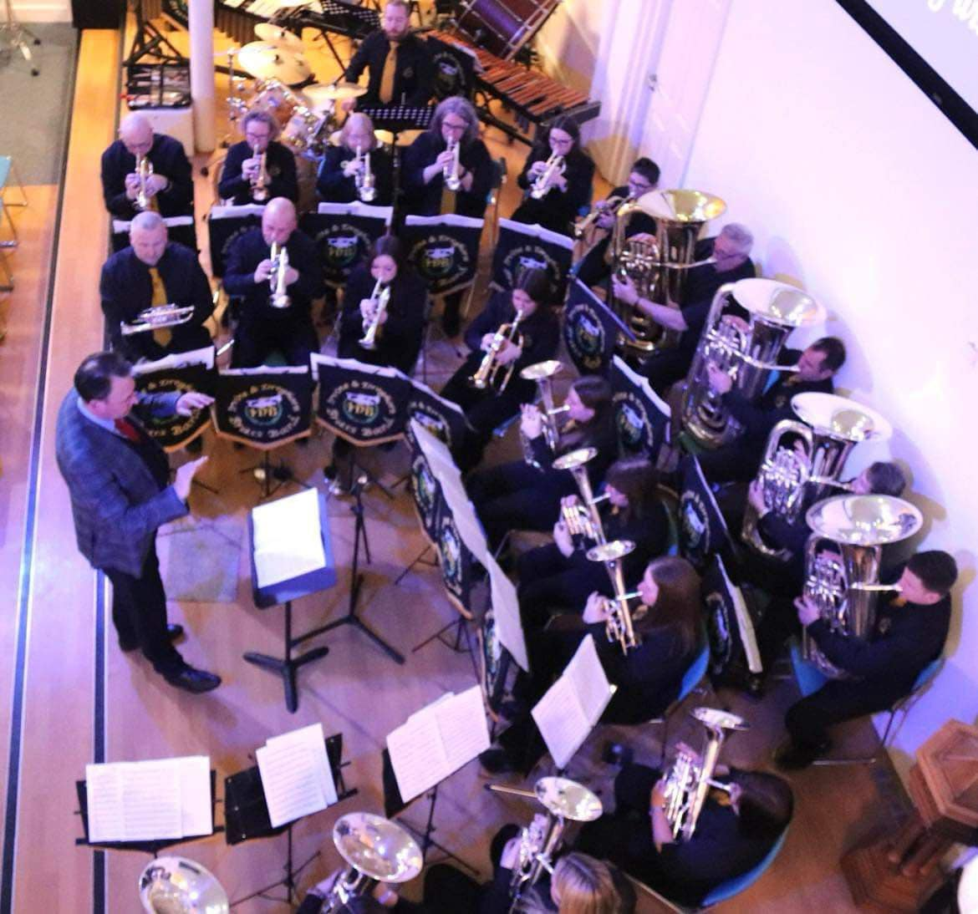 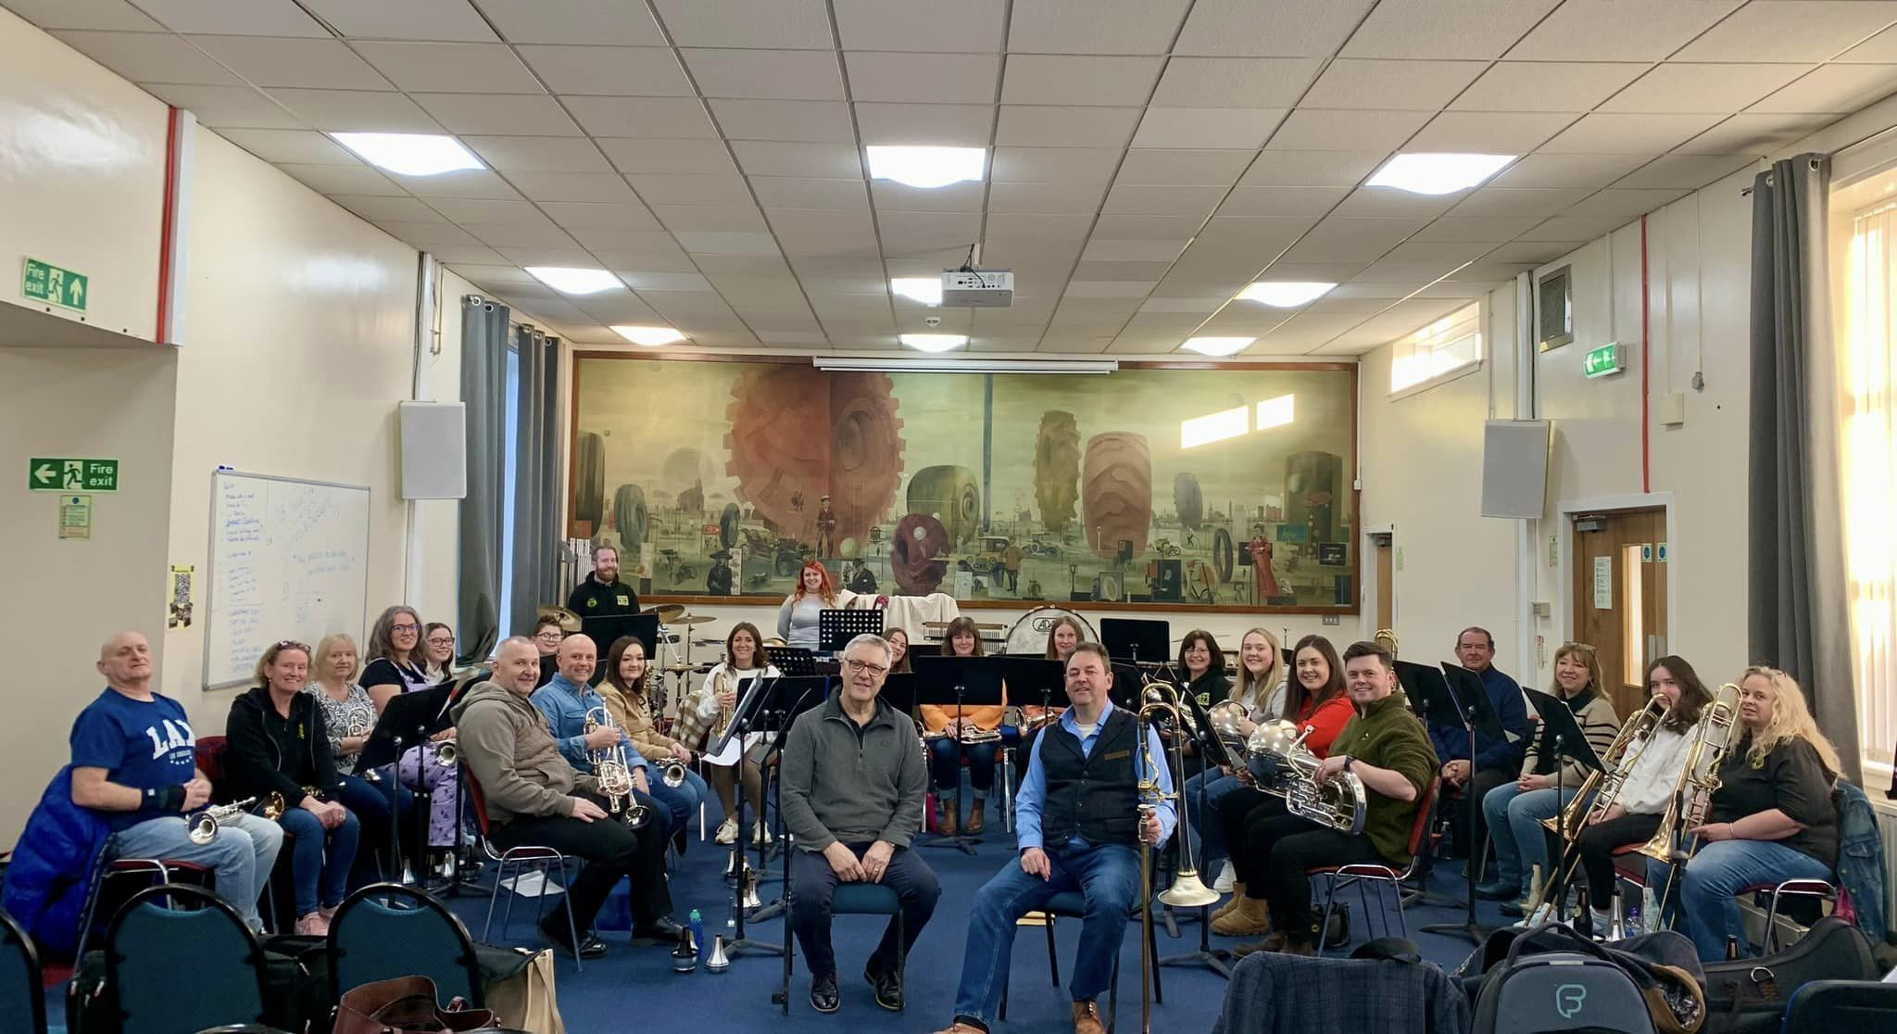

Contest band in concert Rehearsal / preparation

Christmas carolling at Braehead Concert in Riverside Hotel, Irvine