Navigating the site on a mobile phone

The website looks a bit different if you’re accessing it on a mobile phone, so we’ve pulled together this short photo guide to help you if you’re not sure what to do.

Step 1: Find the menu button
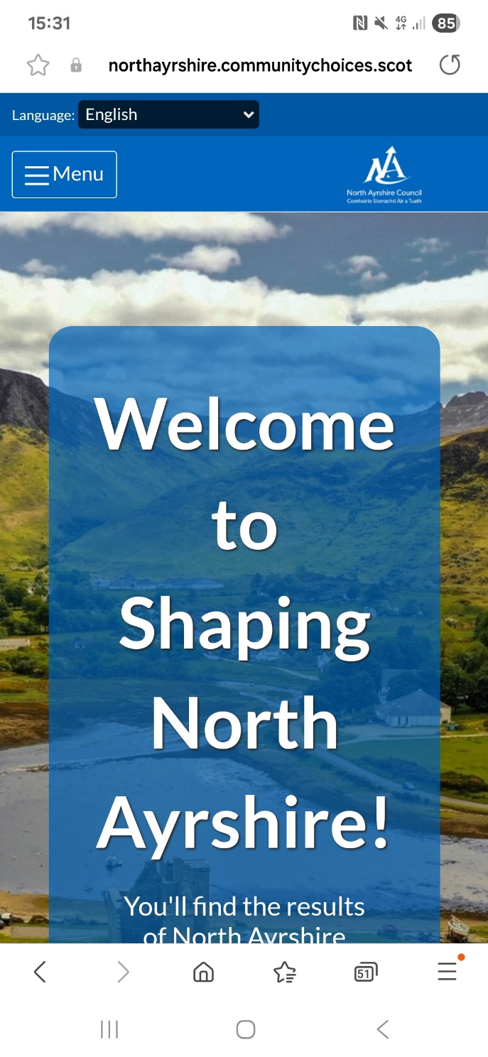
On a mobile phone, there is no grey navigation bar along the top of the page like on a computer. All the links in there are instead in the Menu on the top left hand side of the screen.
This is where you’ll find all the information you’ll need, including where to register or log in to the site; guidance information and any open funding or other community engagement funding

Step 2: open the menu
Clicking on the 3 horizontal lines next to ‘Menu’ will open the drop-down menu.
This will be on any page you open meaning it’s easy to navigate to the information you’re looking for
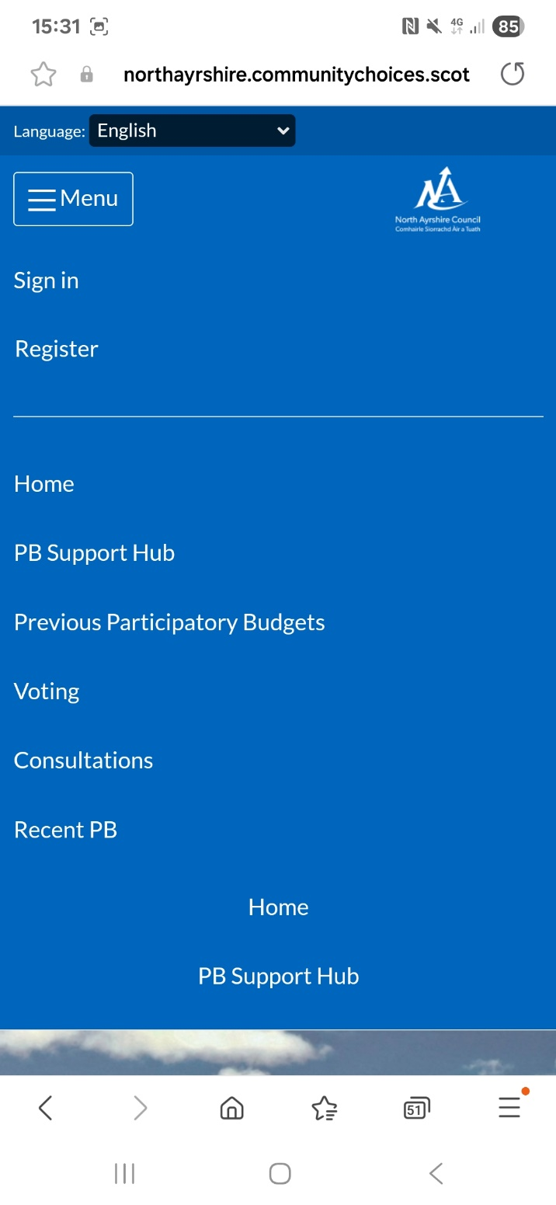

If you’ve already created an account, click on Sign In
If this is your first time creating an account, click on Register

The PB Support Hub includes information on in person information sessions, the criteria for this year’s funds and helpful guidance on your application

Any live processes will be listed here, such as PB, grant funds and consultations – just click on them to open the relevant page

Further information on logging in and creating an account can be accessed in the PB Support Hub.

