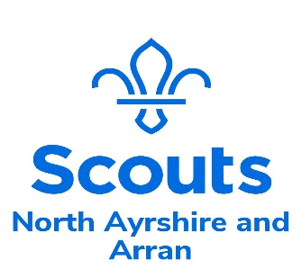

52nd. Ayrshire -Saltcoats
Budget for Camp
June 2024
Friday afternoon - Sunday afternoon

No. | Item | Cost
 | Camp Hire and Activities | £1610.00
 | Archery | £ 250.00
 | Meals , snacks , fruit , hot and cold drinks | £1625.00
 | Crafts | £ 125.00
 | Transport costs – awaiting quotes
 | Total | £3610.00

Please note it is our intention to further reduce costs by fundraising and grant writing

Yours in Scouting
Carol Boyd
Carol Boyd
Group Scout Leader
52nd Ayrshire- Saltcoats

