STEVENSTON LIBRARY
Current Hours/Proposed Hours

 | Monday | Tuesday | Wednesday | Thursday | Friday | Saturday | Total
Current | 10 – 1 & 2 – 5 | 10 – 1 & 2 – 6 | 10-12.30 | 10 – 1 & 2 – 5 | 10 – 1 & 2 – 5 | 10 – 12.30 | 30
Proposed | CLOSED | CLOSED | 9.30 – 1 (Alternative weeks) | 9.30 – 1 & 2 – 5 | 9.30 – 1 & 2 – 5 | 9.30 – 1 (Alternative weeks) | 16.5

STATISTICS
The pie charts below show -
- the number of books issued each day
- how many sessions took place on public computers
- how many visitors came into the library.
They show the interactions that took place each day the library was open in the last 12 months.
These stats indicate that a Thursday and Friday are the busiest days for borrowing books, the public computer sessions were busy on a Monday, Tuesday. These statistics were taken into consideration and supports the decision to select Thursday and Friday as the main opening days for Stevenston Library with additional opening hours on alternate Wednesdays and Saturdays. Opening Stevenston on these 2 busy days also allows Ardrossan Library to be opened on a Monday & Tuesday, supporting them to be open on their busiest days. As Saltcoats Library has 52% of the book issues, it will become the Locality Library in the Three Towns. Partners will be able to key-hold to maintain services at Stevenston Library.

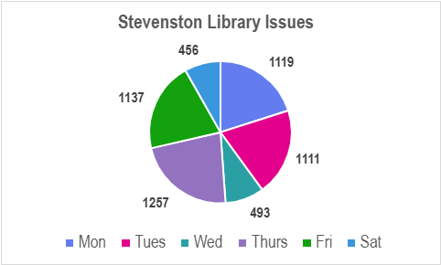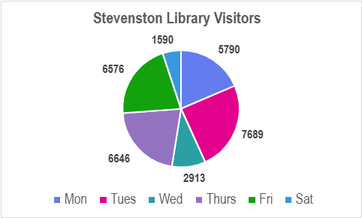

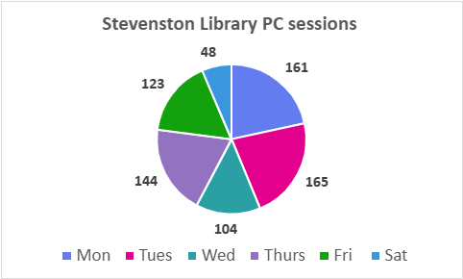

Events
Our statistics also show that, from April-September Stevenston Library hosted 340 events which involved 8 of our regular partners, 3 regular community groups and 5 groups led by the library staff. Changing the opening days would impact on 2 of the partners, 3 community groups and 1 library led group. To help offset the potential impact, we can offer our regular partners and community groups the opportunity to be keyholders for the building and use the space when we are not open to the public, hence keeping continuity for them and minimising the impact. It is anticipated that the impacted community group may also be able to meet on another day. This will be discussed with them directly. The groups led by the library staff can easily be switched to another day.
Wi-Fi Sessions – 54,260 sessions in previous 12 months
The public Wi-Fi will remain available 24/7 however, the ability to Wi-Fi print will be impacted by the proposed changes. The service would be available in Ardrossan and Saltcoats Libraries on the days Stevenston is closed.

Supplementary information
The heat maps below give the breakdown of book issues and the public computer sessions per hour with sessions shaded green being the busiest and red quiet -

Book issues per opening hour
 | 10 - 11 | 11- 12 | 12 - 1 | 2 - 3 | 3 - 4 | 4 - 5 | 5 - 6
Monday | 196 | 165 | 138 | 270 | 227 | 123
Tuesday | 304 | 171 | 148 | 175 | 167 | 93 | 53
Wednesday | 171 | 235 | 87
Thursday | 198 | 209 | 247 | 201 | 252 | 150
Friday | 172 | 233 | 113 | 209 | 300 | 110
Saturday | 168 | 197 | 91

Public Computer Sessions per opening hour
Day | 10-11 | 11-12 | 12-1 | 2-3 | 3-4 | 4-5 | 5-6
Mon | 43 | 18 | 13 | 39 | 36 | 12
Tue | 34 | 19 | 6 | 46 | 38 | 18 | 4
Wed | 81 | 21 | 2
Thu | 37 | 21 | 12 | 36 | 29 | 9
Fri | 24 | 18 | 5 | 41 | 30 | 5
Sat | 32 | 15 | 1

