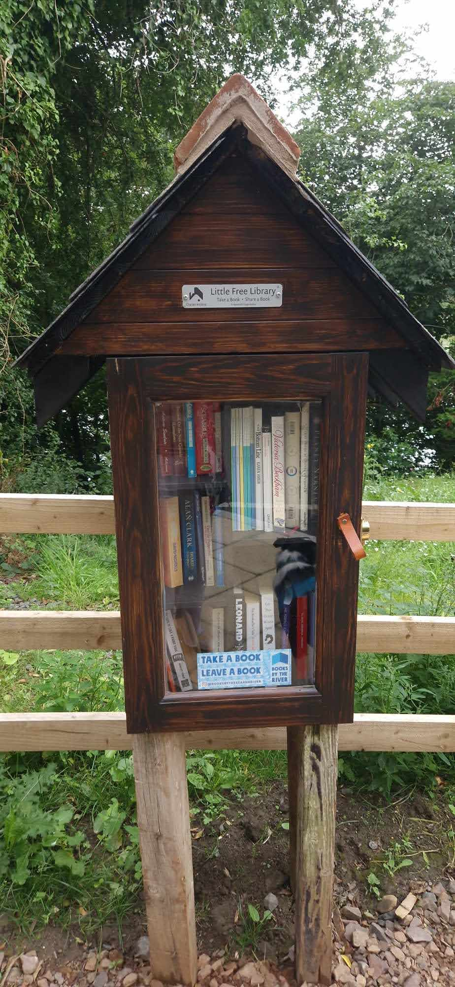
An image of a little library, such as the one we’re intending to add to Skelmorlie Community Garden.

