Why KONEKT deserve this fund:
We deserve this fund because the young people we support deserve it. They deserve a space to grow and explore - that is KO-NEKT’S mission. By gifting this opportunity to us you are having a direct positive impact on under-served groups in Ayrshire. KO-NEKT has an award-winning history of providing excellent support and continues to close gaps in the system. With this fund we will continue this work to include a sensory room.
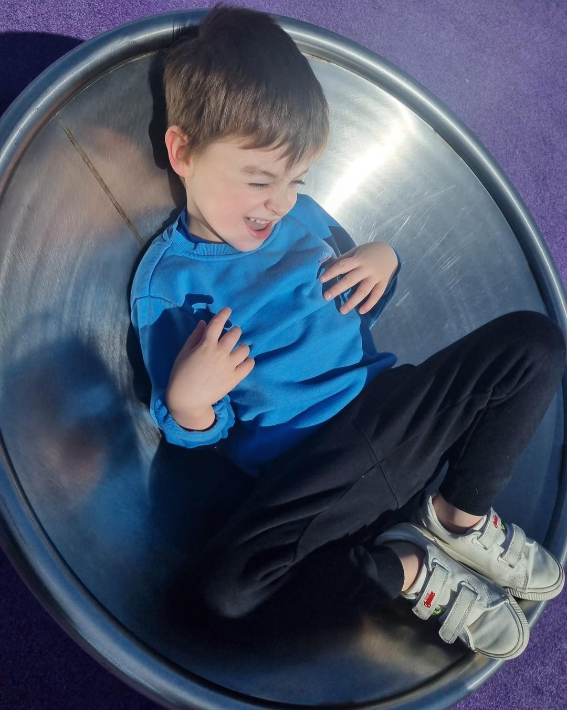
Our young people and staff team are paving the way for people with ASN to live life to the fullest. We deliver life-skills groups with potential for SQA qualifications, group sessions to build real, lasting friendships, and integral community support in the Ayrshire area and beyond. Our sensory room is next on our list. If KO-NEKT is awarded this fund, you will see real community impact as KO-NEKT supports a majority of young people with ASN in the area. You would be gifting our young people emotional regulation tools, a feeling of safety, new channels of communication, and giving local families a safe inclusive space for their young person to explore their sensory needs safely.

