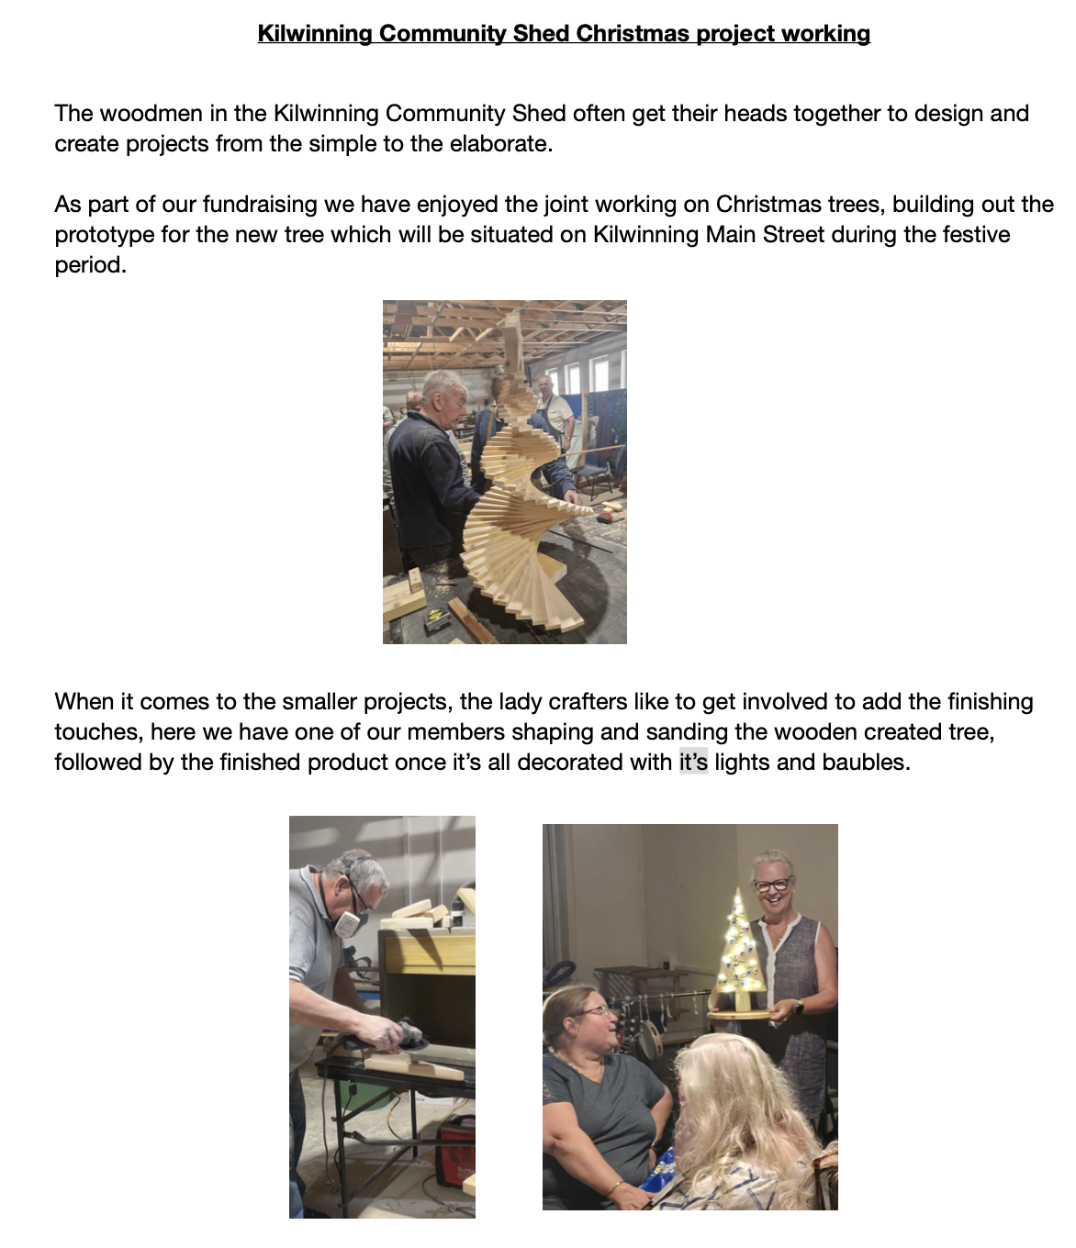
Kilwinning Community Shed Christmas project working

